**Beautification of ToDo website**

Following are the screen shots from the website ToDo

**#1 main page of the website** : http://localhost:8080/

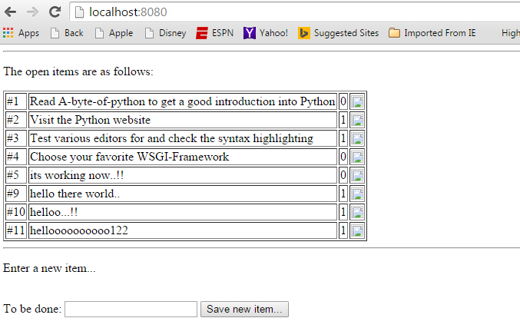

**#2 Enter a new item** -> Save new item..

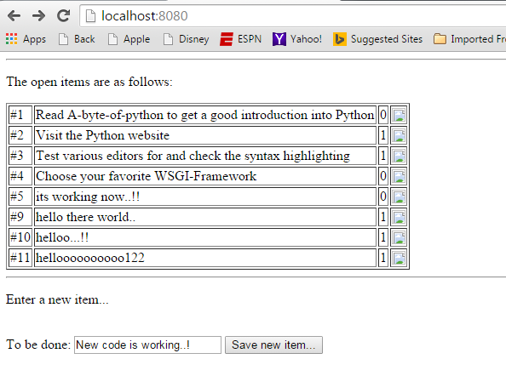

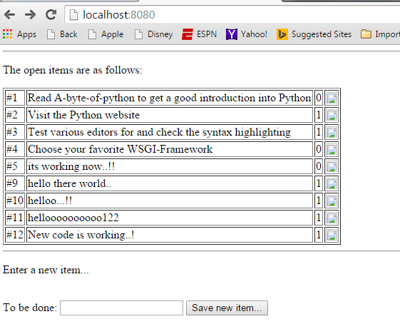

**#3 Delete an item** (in this case item 9) -> Confirm deletion..

